

**Why database table needs Primary Key**

1. For good practice in database designing, we have to maintain primary key in every table.
2. Primary key is use to uniquely identifies each row/record in a table.



**Natural key**

1. Primary key is made up of real data in table, that primary key is called as natural primary key.
2. For example,

In HR database, Employees table having ‘Employee_id’ column which is unique and not null

and we can call this real data because every employee should be identified by its’ Employee_id.

1. 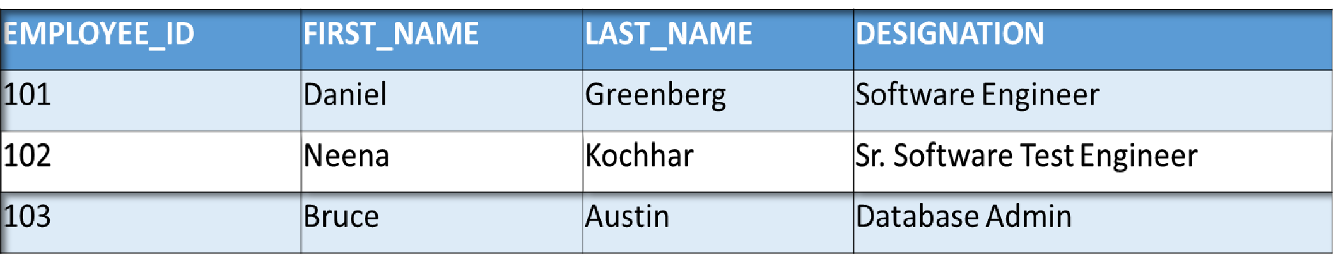Here we can make Employee_id as primary key in Employees table and this primary key is called as natural primary key.



**Surrogate key**

1. Some times in database table we cannot make primary key from real data.
2. In this situation, we have to add one artificial column in table which is having unique and not null values,

and make this column as primary in table.

1. This primary which is generated from artificial column is called as Surrogate key.



**Surrogate key**

* Example:

If we have to maintained history of employee table then Employee_id should be not the primary key

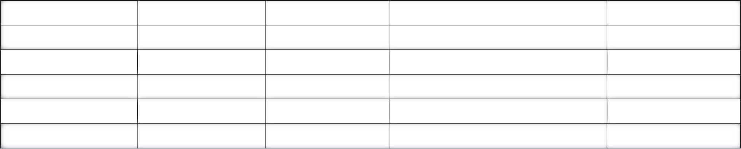column in table, because there are chances of duplicity in Employee_id column.

|  |  |  |  |  |
| --- | --- | --- | --- | --- |
| **EMPLOYEE_ID** | **FIRST_NAME** | **LAST_NAME** | **DESIGNATION** | **CREATED_ON** |
| 101 | Daniel | Green | Jr. Software Engineer | 03-01-18 |
| 102 | Neena | Kochhar | Software Test Engineer | 03-01-19 |
| 103 | Bruce | Austin | Database Admin | 06-05-20 |
| 101 | Daniel | Green | Software Engineer | 19-01-20 |
| 102 | Neena | Kochhar | Sr. Software Test Engineer | 03-02-20 |



**Surrogate key**

* + To resolve this problem of primary key in employee table, we have to add column EMPLOYEE_KEY column

which should be unique, not null values.

* + And we can make EMPLOYEE_KEY as primary key in employee table, as this primary is also called as surrogate key.

|  |  |  |  |  |  |
| --- | --- | --- | --- | --- | --- |
| EMPLOYEE_KE**Y** | **EMPLOYEE_ID** | **FIRST_NAME** | **LAST_NAME** | **DESIGNATION** | **CREATED_ON** |
| 1 | 101 | Daniel | Green | Jr. Software Engineer | 03-01-18 |
| 2 | 102 | Neena | Kochhar | Software Test Engineer | 03-01-19 |
| 3 | 103 | Bruce | Austin | Database Admin | 06-05-20 |
| 4 | 101 | Daniel | Green | Software Engineer | 19-01-20 |
| 5 | 102 | Neena | Kochhar | Sr. Software Test Engineer | 03-02-20 |